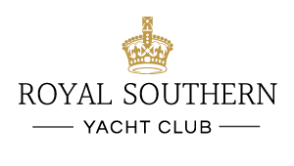
Opening Times: Thursday – Saturday 18:30 – 21:00

River Room Prix Fixé
2 Courses £20 (£18.00)

3 Courses £25 (£22.50)

Starters

French Onion Soup Cheese Croute
Crab Beignet with Crushed Peas & Lemon Gel
Beef Carpaccio Shavings of Parmesan and Herb oil

Pork Prune and Ham Terrine with toasted Sourdough and Apple Chutney

Poached and Smoked Salmon Tian Olive oil and Caper Dressing

Camembert Wedge with a Cranberry and Port Sauce

Mains
Grilled Ribeye Steak, Sauce Diane

Chicken Supreme Stuffed with Asparagus & Sun-Dried Tomato Mousse, Spinach Cream Sauce

Goan Fish Curry with Basmati Rice

Roasted Salmon Fillet with White Wine Prawn Sauce

Caramelised Onion & Brie Tart, Balsamic Syrup

Menu subject to availability. Please be aware that some dishes may contain allergens.
Please make a member of staff aware if you have any specific requirements.
All non-members will have a 15% service charge added to their bill.
(PRICES IN BRACKETS ARE THOSE CHARGED TO MEMBERS USING A LEVY CARD)
15.02.2019

Desserts

Lemon Posset and Shortbread
Frozen Raspberry Parfait
Cheese Selection, Quince Paste & Crackers
Selection of Ice Creams & Sorbets

Menu subject to availability. Please be aware that some dishes may contain allergens.
Please make a member of staff aware if you have any specific requirements.
All non-members will have a 15% service charge added to their bill.
(PRICES IN BRACKETS ARE THOSE CHARGED TO MEMBERS USING A LEVY CARD)
15.02.2019

